Example of Plots for Visualization in Project “Cardio”

Note: The following plots are given as example. They incorporate minimum required elements

Plot 1 – Pie Chart

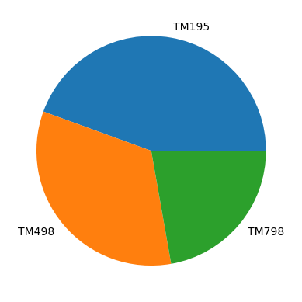

Plot 2 – Histogram Distribution

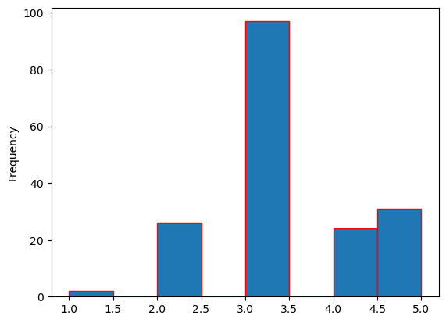

Plot 3 – Barchart for Income

